**Meeting notes are in reverse chronological order (most recent at the top)**

July 29, 2021

Colt Meeting Notes

Week 10

Updates:

* Log in
* Click on Network Performance KPI’s
* Can select the time period at the top left corner
* The top part is showing what is happening to the network and the bottom part has all the information about the application
* There are two ways to get the data: API call or csv file
* You can select all the metrics for what you’re interested in analyzing (i.e. delay variation, packet loss, jitters) from the ‘Series’ tab in the upper left corner and narrow it down to a time interval
  + Once the information is filtered down, it can all be exported to a CSV
* The bandwidth monitoring process happens on two separate ports for each direction (bandwidth in one direction is measured on one port and bandwidth in the opposite direction is measured on another)
  + We’d have to look at each separately under ‘Circuit Bandwidth’ from the Network KPI’s Dashboard and export each one to a separate csv file and combine them
* We can ask questions from the tab in the bottom left corner
  + Almost like a live chat
  + Button to click on: 
* There should be 4 VR streams running continuously over the connection
  + The cumulated bandwidth wouldn’t exceed 15 megs in total
  + (can’t select anything more than this)

July 22, 2021

Colt Meeting Notes

Week 9

Updates:

* **Anvil changes:**
  + Change “Pick QOS Level:” string to “Pick QOS Level SLA:”
  + Fix the position of the “Choose the app:” string
    - Can be indented to line up with the rest of the text above and below
  + Add a decimal range for the QOS levels
  + Show some sort of scale for the QOS level that indicates whether the number is good or bad
    - Example: 1 is good and 5 is bad
  + In the parameter selection, we should add a characteristic of how far back a time window is. For example, the user can choose to go back 5 or 10 minutes from now (or maybe even hours/days)
  + We can also add graph summaries of the statistics throughout the day.
  + Round all the decimals in the characterization and network traffic sections
  + When it comes to both AR and VR, we need to show the SLA and measure it
  + Round the current suggested bandwidth to the 2nd decimal place
  + Maybe add a brief comment of what the “Characterization” and “Network Traffic for VR” represent
    - Add units to the columns and make sure the first letter of each word is capitalized (Ex: “packet loss” should be “Packet Loss”
  + **Graph:**
    - Is it an automatically generated or a manually created graph?
    - Increase the size
    - Add a dotted line that represents the mean of traffic
* **Data updates:**
  + Will have it be Wednesday (7/28) at latest
  + We’ll have access to the client machine to see the quality of the VR
* **General updates:**
  + We’re presenting our progress/overall project at the Innovation-X Seminar on Wednesday, August 4th, at 10am PDT (in 2 weeks).
    - Begin working on UI changes and prepare the slides for the presentation.

July 15, 2021

Colt Meeting Notes

Week 8

Updates:

* First phase of Anvil UI Demo is completed
  + Allows you to upload a csv file to generate a line graph for the mean network traffic and suggested bandwidth
  + Displays more information about the network
* Colt updates:
  + Still in the setup process regarding the data
  + Working on setting up a little device or piece of hardware that measures the network information better / more accurately
  + Both Valéry and Francesca will be on vacation starting in August (or last day of July)

July 8, 2021

Colt Meeting Notes

Week 7

Meeting with everyone

* Updates:
  + We now have information on the KPI metrics that Skylight generates
  + There are 3 pdf’s attached in the colt Slack channel with great documentation
  + Message from Valéry:
    - The active PM metrics are for the active testing using TWAMP and the Flowmeter bandwidth monitoring using the smart EP
    - The capture sensor metrics are for the application PM. The metrics can apply across all the layers/protocols, but the most important part for the PoC is to use TCP metrics, especially as the VR stream will be using HTTPS.
    - The end user response time is an important metric we calculate. (More info about how it’s calculated in one of the pdf slides)
* Questions to answer:
  + How long are the periods/intervals? Is there some sort of rate of bytes we can analyze?
    - Seems like it might be custom
    - Ikhlaq mentioned that over a second or minute would be ok, but we don’t want to be too broad because if something happens within 10 seconds and you only have data per minute, then we’ll miss that critical piece of information
      * Try 5 seconds, 10 seconds, etc…
    - Valéry mentioned that we can set the bandwidth stream.
* Plotly code for Anvil (2 line charts on top of each other)
  + First one is a bar chart
  + Second one is also a chart and you could put both lines charts on top of each other
  + Code:
    - #self.build_ii_graph()
    - figs = [go.Bar(y=[score_ii,tru, res, div, bel, al, col,com, inn], \
    - x = ["Overall","Trust", "Reslience", "Diversity", "Belief", \
    - "Allocation", "Collaboration", "Comfort Zone", \
    - "Innovation Zone"], name='Components'), \
    - go.Scatter(y=[tmp, tmp, tmp, tmp, tmp, tmp, tmp, tmp], \
    - x = ["Trust", "Reslience", "Diversity", "Belief", \
    - "Allocation", "Collaboration", "Comfort Zone", \
    - "Innovation Zone"], name='Overall') \
    - ]
    - self.plot_1.data = figs
* Anvil cloning issue
  + There’s a way to copy a link to make a copy of anyone’s app
  + Ikhlaq’s app: <https://anvil.works/build#clone:O3AUBER3OIXAN6YM=MWHDXVSAJBZAOCTHP722JAE6>
* Tasks/Next Steps:
  + Create a fake dataset and make visualizations on Anvil based on that
  + Review the pdf files Valéry sent and figure out which parameters and features we want to use

July 1, 2021

Colt Meeting Notes

Week 6

Meeting with everyone

* We’re going to have a meeting with Deb soon. It has yet to be scheduled, but we’re waiting to hear back from him to see what day/time works best.
* Sample log event files and fields of data
  + Valéry is going to meet with the VR application team next Tuesday to see if he can give us the real-time data.
  + Ikhlaq mentioned that we only need about 1-2 columns (time and bandwidth for rate of traffic over hourly intervals - for example), and we can add more features later on.
  + In case it takes more time to receive the data, we can just create some simulated data or use a public dataset that contains information about bandwidth and build our UI/app with that (for the time being).
* Anvil app builder:
  + <https://anvil.works>
  + Form 1 and form 2 are running locally in the browser by converting your code through Java, while the server module is connected to the database/server.
  + Form 1 in our case would be the application settings.
  + Form 2 in our case would be the algorithm settings.
* Task for students: Go to Anvil and make a free account.

June 24, 2021

Colt Meeting Notes

Week 5

Meeting with everyone

* Why is the type of application relevant to the UI?
* The network is able to be adaptive and react in real time depending on what happens to that application.
* The idea is to create a challenge for the VR application. We could probably work with one VR server with multiple streams tied to it.
* Ikhlaq’s comments:
  + The type of traffic (application - AR/VR) shouldn’t be considered on this UI since we should be making a prediction regardless of what application it is. This is because in the actual use case, it’s unclear/unknown as to what the application is. We should just focus on which link and QOS are the ones of interest. Through this mechanism, some proposals are made for a new bandwidth.
  + Take some data that comes from the network to understand how it’s serving the QOS and then propose what needs to be done. Figure out whether we want to increase or decrease the limit assigned on that link (dynamic part).
  + Imagine a screen with a different application that’s predicting what you should do for the second application. We can assume each is a separate link, determine how much bandwidth you want, and in the end, add all the individual bandwidths to set the total bandwidth (sum).
* Francesca’s comments:
  + Increase bandwidth for that specific application, not the link overall. Such as, one service can be using 1/3rd, another can be using 2/3rd.
  + The network is able to understand the specifics of the application. They want us to deliver its dynamic SLA based on real time.
* Noor’s Notes:
  + user input features (what the bandwidth is currently set to as part of current network settings, specify qos levels as low/mid/high and assign those qos measures to some beta value, specify network, ability to select specific link that you would like to adjust bandwidth for)
  + some links might be running multiple applications so we need to specify the type of input data: ar/vr application
  + characterization: map the application traffic data to qos level (return as part of output)
  + total (optimized) bandwidth=sum of what current bandwidth is set to and all adjustments made (increase or decrease)=output as int
  + algorithm: adjust the bandwidth and it fills and again " until the application network settings on edge of link reaches sufficient bandwidth for qos measure (max out until it is set high enough so traffic never sees boundary)
  + define test: has to be something pulling the bandwidth down so we need to keep trying to drop it with each adjustment we make (check for optimal bandwidth setting)
  + output: line plot of mean network traffic over one minute intervals with two horizontal lines representing current and optimized bandwidth, current suggested bandwidth and optimal (adjusted) bandwidth, characterizations (descriptive statistics) and qos measure (assigned to some beta value)

June 17, 2021

Colt Meeting Notes

Week 4

Meeting with everyone

* Steps/approach
  + Link, traffic, specific QOS, and bandwidth from different applications to estimate overall bandwidth
  + The first diagram is what Ikhlaq was talking about last week with setting a cutoff and observing the bandwidth threshold, SD’s, mean, etc., to determine the overall performance of the network.
* 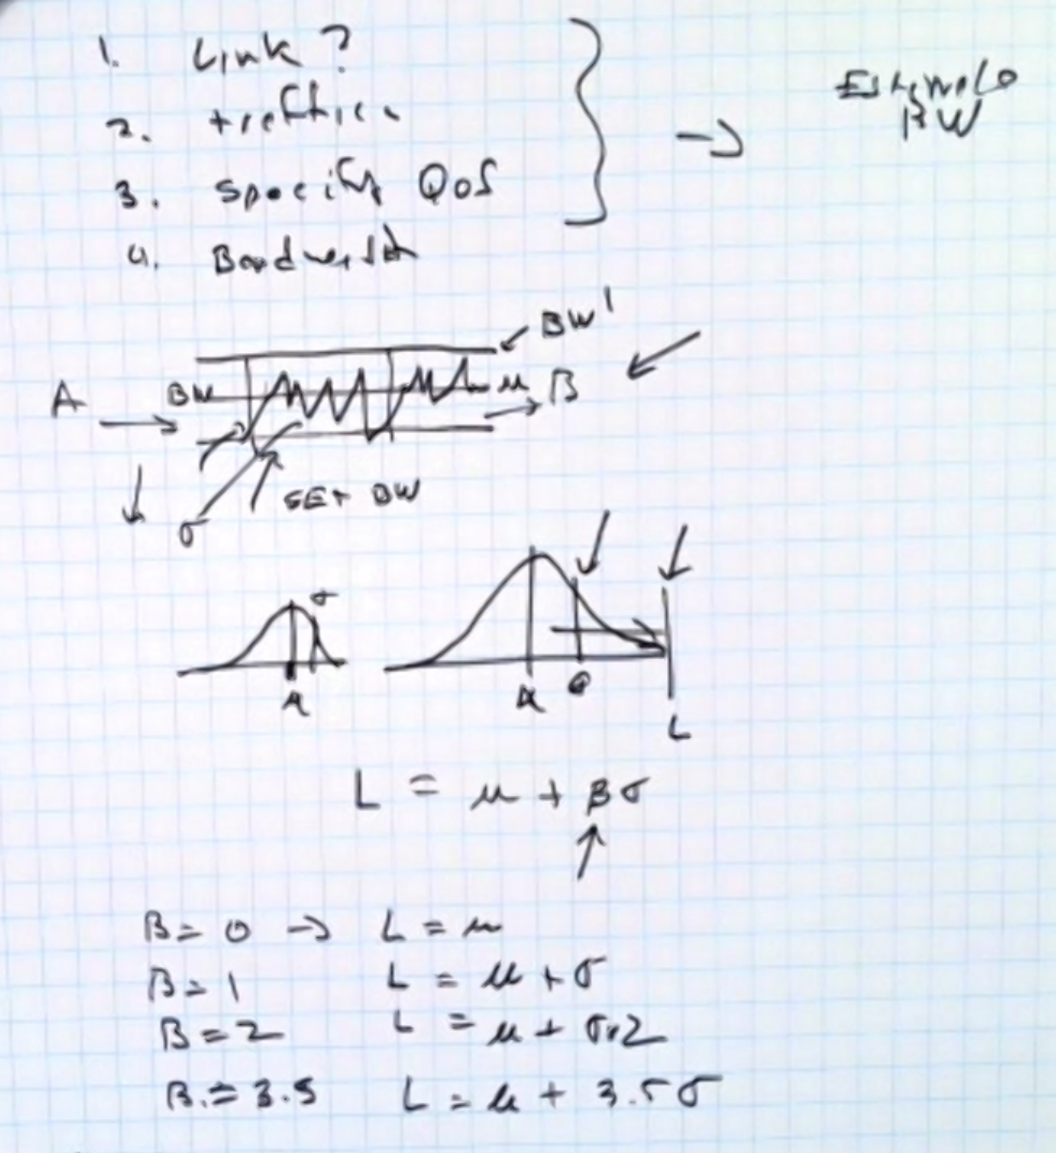
* We can see which beta provides the best experience based on our calculations.
* How do we determine the cutoff? We’re going to pick a level, such as 3.5 SD’s over mean, using a Gaussian model. We’ll then tune the hyperparameters and see what works best.
* Phase 1 is to make calculations (SD, mean, etc.) and apply them into the model. Once we have the output/information from that, we can go into phase 2.
* Phase 2 is to go back and see how the applications were operating with different betas (ex: was VR operating well with beta=5?).
* Colt wants us to show that the VR adapts through our algorithm based on network and so on.
* 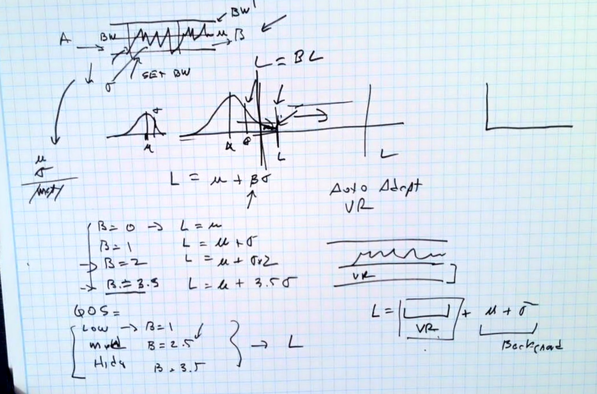
* We can observe the outcome of the different betas we use and tune our model/parameters based on that.
* 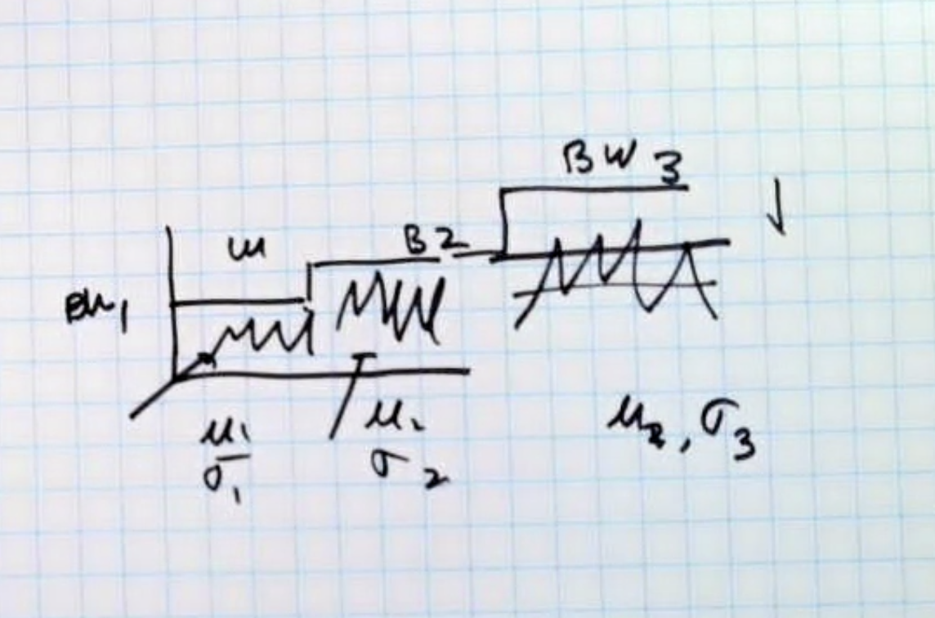

June 10, 2021

Colt Meeting Notes

Week 3

Meeting with everyone

* The control from the bandwidth will come from the UI
* You can also measure the network traffic
* VM platform reports RAM, VMs, CPU, etc.
* The entry point of the different clients and several machines will be a single client host.
* **Change name of the project.**
* Ikhlaq’s perspective: We’re reading data from all the different applications/ports and we’re using it to make an estimate on how much bandwidth to assign on links to make it low enough but good enough on those applications.
* Francesca’s response: What the industry is looking for is a network that adapts to the requirement of the application over time. Take data from the network/application to see how it’s acting. Based on that, we should determine how it’ll scale the bandwidth.
  + Measure dynamic SLA (service level agreement) in a second step
  + Being able to adjust network on that link
* Input
  + Application traffic
  + Network settings: bandwidth
  + QOS level (how good the quality is going to be one application at a time)
    - Is it static or dynamic
  + KPIs: monitoring performance of KPI of network (packet loss, jitters, delay) and derive whether the bandwidth should be increased or decreased
* Output
  + New setting for all of this
* First approach (Phase 1):
  + Looking at traffic and packet loss to get a number or measure of SLA and based on that also upgrade the bandwidth. Based on the parts of the graph that are above the horizontal line (flow exceeds limit), we can observe that there might be packet loss for example, so we’d use that to determine how much bandwidth to upgrade.
  + Take data from network and provide information about performance
  + Automatically decide what to change to follow needs of traffic
* Second approach (Phase 2):
  + Take one VR application. From that, we have a mean bandwidth, variance, etc. and we can say that if there are n number of VR applications, then we can show how much bandwidth is needed. This would be (n times the mean of bandwidth) + (square root of n times the SD).
* Student task: Think about what kind of UI will let you take data but provide the value of the settings we talked about.

June 7, 2021

Colt Meeting Notes

Week 3

Demo with Accedian

* Network performance monitoring between 2 different sites
* Combined with data that is being collected and then added to the cloud, which is where we can get access from
* Send packets continuously (every x ms) between 2 sites (test client using the app)
  + Collects packet delay, packet delay variation (IPDV), packet delay variation (PDV), packet loss, and bandwidth
  + Monitors size of packets
  + Can produce an additional series of metrics by analyzing packets between different locations or KPIs at different layers
* The background traffic is running at layer 3 (IP layer metrics)
* Network - Active Performance Monitoring
  + Skylight will test the connection every 1-100ms and report KPI metrics every 1-60 seconds
    - Packet delay,
    - Packet delay variation (IPDV)
    - Packet delay variation (PDV)
    - Packet loss - % rate, count, min and max burst size
    - Bandwidth (optional) - from live traffic min, max average per flow
* Passive Network & Application Performance Monitoring
  + Skylight will monitor the live traffic and report network and application transactions every 60 seconds
    - TCP layer - End User Response Time (EURT), Connection TIme (CT), Round Trip TIme (RTT), Data Transfer Time (DTT), Server Response Time (SRT), Retransmission Rate (RR), Retransmission Delay
    - HTTP - Response time, errors, volume, hits/performance - per host/server/client/URL
    - DNS - Response time, errors, volume - per host/server/client
    - Applications - Response time, errors, volume, hits - per host/server/client
* The way the system is designed is to produce data continuously.
* Data is stored in 2 different ways
  + Application based
    - Querying to extract from it
  + Network active based
    - Can use Zeppelin to query/extract the data
      * Zeppelin: <https://zeppelin.apache.org>
* Accedian API: <https://api.analytics.accedian.io>
  + <https://api.analytics.accedian.io/session.html>
* Can export data into csv from a graph or can use raw API calls and duplicate (JSON format)

—essentially send packets continuously between two sites (and configure what continuously means) and aggregate stats on periodic basis

—creating background traffic and then configurations and layers of the network and secondly measuring (the controls over what you send is rate in between packets and how large the packets are to set bandwidth of what you are sending)

—looking at doing real client to server application access (layer 4 and layer 7_

—categorize application network traffic and produce additional series of metrics: analyzing packets and kpi that gives **information about how well application is responding across network, allowing customers to correlate performance of network with that of application**

—network connects two sites and test client using app on right and left

—sending application layer requests and response

—synthetic and real user packet

—aggregated data on connection between two sites (larger in the real world so hundreds of thousands of continuous tests)

—constrain to test set, will be more manageable quantity of data

—stream into cloud (gain access there), application running there running streaming analytics back into cloud wherecolt processes and stores

—run apache spark cluster running in cloud and data is persisted to disk (don’t worry about this part)

—look at data through a test environment (60+metrics for plots etc.)

—csv export of data into a file from graphical front end

—use chrome developer tools to look at raw api calls being made (return json)

—ideal graphs: mean and sd of packets per second (convenient) total number of packets, packet loss —> can look through metrics (ex: packets sent or received)

—can do it in the ui and export or look at api calls and duplicate them

—metrics called capture are for real user traffic measured and twamp are for background traffic (rfc standard for layer 3 performance measurement— controlled in different interface/api)

—by default continuous background traffic running

—characterize ar/ver (run vr stream) one single application and client or multiple clients running the same physical host

—would tcp used for vr streams? vr partner will confirm in coming days

—apache zeppelin (python based notebook)

—what to write to pull data into programming environment: zeppelin allows you to create notebooks and use python and r and scale to manipulate data

—can access through user interface or api or zeppelin (running on instance of application specifically for this test on cloud)

—sandbox system that will be provided for project by accedian

—to figure out: what is the design of the things we are supposed to build and what input do we need from it and will come back and ask about the easiest way to get that

—can provide access to interface or simple documentation of how they do these things. will start with what the design is for system output and then decide if we need to run a test with background data

—likely will not need more than 3 metrics

**next steps:** give us test login or any links (how to use)

graphic user interface is good start (easiest to be able to see what we want t get)

way of dumping raw data into csv file (what is the best way to extract the raw data: for some csv exports from tabular view)

—will get access and access to platform

**tools:** apache zeppelin (create shared notebook through shared user)

using python with spark (load into spark object in order to access data)

would need to know what to load

object is specifically stored as a link (everything related to link)

apache parkay: data storage format (for each tenant with ui id there is a parkay file for each specific data)

can write python or whatever into it

—twamp-sf refers to session type

June 1, 2021

Colt Meeting Notes

Week 2

Logistics

* Monday meeting debrief w/ Elisa and Ikhlaq
* Wednesday check-ins with Ikhlaq (10-11 am PDT)
* Thursday meetings (8:30-9 am PDT) with Colt and entire team

Project

* Start visualizing the low tech demo and all the components required
* Statistical multiplexing
  + When one is using more, the other might be using less
* The team will be using different UIs:
  + one will be on-demand where you can change the bandwidth
  + the other will be an analytics UI where you’d be able to find the data and download the KPI
  + the third one will be remote connection to the client VM where you can check the quality of the server application
* Goal: Decreasing the bandwidth available to reduce the costs while maximizing delay and user happiness
* Focus on one application (VR)
* We’re going to want to know the mean, standard deviation, and variance of the distribution of network traffic and the source itself (VR)
* Set up a separate time for a demo regarding the data
* The nodes are routers and the bandwidth between them can be controlled by the network below
* MPLS (Multiprotocol Label Switching) technology
* UI: represent stats of application performance and set the bandwidth remotely to clients
* System Architecture slides:
  + QOS (quality of service) next to user happiness
  + Optimize bandwidth for minimum cost
  + Reduce packet loss
* What does the screen interface look like -> screen with input section (desires qos) and output (graph of network and measures of current qos, bandwidth, and the delay that the network experiences on the link)

Demo

* Can click on any port and modify the bandwidth

May 26, 2021

Colt Meeting Notes

Week 1

Low Tech Demo Slides

* Who will use it? (1 slide)
* What will the user see? (1 slide)
* More info: <https://www.innovation-engineering.net>

Information about the project:

* Colt’s POV
  + There are a variety of applications and one user is using all or most of them.
  + The user assigns the bandwidth they need on the platform (<https://ondemand.colt.net/#!/login>), which is pushed onto the network element automatically.
  + If there are a variety of locations, the apps are all running on those servers.
* Adjusting elements of the network based on traffic conditions (Ex: provide more bandwidth in 2 locations that are busier at a certain time)
* Input: log file or livestream of data (rough information)
  + Stochastic demand
  + Excel or csv file
* Pay attention to what can be adjusted and controlled
* Look at the data that’s coming in and determine how performance can be improved through increased bandwidth and reduced delay → increased user happiness (user perspective)
* Control the networks based on the types of services so that we can give a better service (make the network adaptive)
* Can potentially put props in the networks and get data that way
* Pay attention to all these different applications, see how much demand is against each one or how much bandwidth is required, and sum the estimated bandwidth for all of them up to make a guess of what that total number would be.
* These applications all have different amounts of delays, jitters, etc., so look at the list of these applications and start with how you characterize one of them, such as VR, and then apply the same process to the rest after.
  + One option is that different logs exist, so we can look into each one.
  + Another option is to write telemetry hooks and then analyze them
  + A third option is to tweak parameters, check the bandwidth, and collect the KPIs (delays, jitters, etc.)

Action Items:

* Slide version of the story (direction of low-tech demo)
* **Deadline: Monday, May 31st**
* Prototyping the future (improve sight and all resources)
* If students picked up project in fall what would they contribute
* Purpose: for everyone to learn a common process (make as much progress as possible)

Project Ideas:

* Automatically adjusting certain elements of the network based on traffic conditions so more bandwidth can be added between two locations (for example) if there is more traffic or usage in a location at some time. by having a measure of where traffic and what they are doing (log file data or live stream) data tells us rough information and there is basic topology of what is connected but basic idea is what can be adjusted or controlled. The idea is to automatically look at data that is coming in and make decisions about how to improve performance with delay of packet times. parameters we want to control to enable quality of experience for certain applications: increased bandwidth and reduced delay.
* Control network based on data we get from services to provide better experience. key for ar/vr service and iot applications
* What information is easy to get an an input to the system (available data): can put probes in the network (in application server) to get data from server
* Probes about what people are doing and about network (how much traffic is on any particular link)
* Network is made of nodes and links
* Change bandwidth of running connection, install and operate suit of applications or one application (prioritizing vr) on one end would make server up and vr up and on other end user up
* Monitor network connectivity and performance connectivity and kpi’s of the application
* Assign bandwidth (on where?) and push on the network element. in this example you have three endpoints and you have cloud 123 so imagine customer that has 2 or 3 locations and you take bandwidth between internal network
* Test applications: locations and apps running on these servers. the demand for apps comes from ?
* Can start with how do you characterize on application like vr as long as you have a system that can take all characterizations and turn it into effective bandwidth and use
* Goal: watch network traffic and make guesses of how much a particular application uses in terms of mean variance etc. (stochastic model of traffic being used)
* We need intelligence from data and tells about degradation of policy of services
* Math behind knowing how much bandwidth to allocate is not complicated (once you have tolerance for how much you are willing to lose its not overly hard)
* Info on what single uses on the network
* They want the calculation of how much to do the setting on the red line (scope)
* Input you give and output is bandwidth to set on red line
* User interface: (putting probes against one application and let us look at the shape of data that it collects and we can come out with characterization of effective bandwidth and delay requirements) let the team play autonomously on setup so we can play with bandwidth and collect kpi of connection and selection
* Real time effect of changing bandwidth performance (demo with analytics partner) in test environment
* On the application side is user happiness (some between that and packet loss)

